**Software Requirements Specification for**

**( Smart agricultural management platform )**

**Prepared by**

khalid Elabd

Youssef Abdelhaleem Rehan Mustafa Ashraf Mohammed Ahmed Ramzy

Wafaa Gamal

Marwa Samy

## Version: (4.3) Date: (mm/dd/yyyy)

**Supervisors:**

Eng. Mohamed T. Hammad Dr. Asmaa Saad

## Table of Contents

1. **CHAPTER 1 SRS (Software Requirements Specification)**

Problem Statement i

Revision History. ii

1. Introduction 3
   1. Purpose 3
   2. Scope of the project 3
   3. Definitions, Acronyms, and Abbreviations 3
   4. Intended Audience and Reading Suggestions 3
   5. Process Model 4
   6. Stackholders
   7. Overview 4

#### Overall Description

* 1. *Product Perspective*
  2. *Product Functions*
  3. *User Classes and Characteristics*
  4. *Operating Environment*
  5. *Design and Implementation Constraints*
  6. *User Documentation*
  7. *Assumptions and Dependencies*

#### System Features :-

* 1. *Functional requirements*
  2. *Non functional requirements*

## CHAPTER 2 Software Design

* 1. *Activity Diagram*
  2. *Use cases models*
  3. *Sequence Daigram*
  4. *State daigram*
  5. *Class Diagram*
  6. *Component diagrams*
  7. *Deployment diagrams*
  8. *Gantt Chart*

## Problem Statement

Farmers face significant challenges, including inefficient resource management, unpredictable weather conditions, pest infestations, and a lack of real-time data to guide decision-making. Traditional farming methods often result in wasted resources, reduced yields, and environmental harm, while climate change intensifies these risks with unpredictable weather patterns. To address these issues, there is a pressing need for a smart agricultural management platform that leverages IoT devices, AI, and weather analytics to provide real-time insights, predictive alerts, and actionable recommendations, enabling farmers to optimize resource use, enhance productivity, and adopt sustainable farming practices.

## Revision History

|  |  |  |  |
| --- | --- | --- | --- |
| Version | Primary Author | Description of Version | Date Completed |
| 1.0 | Mustafa Aharf | Added Problem Statement  , Purpose sections and Introduction | December 5th 2024 |
| 1.1 | Mustafa Aharf | Added Scope of Project and Definitions | December 10th 2024 |
| 1.2 | khalid Elabd | Added Intended Audience and Stakeholders | December 11th 2024 |
| 2.0 | Ahmed Ramzy | Added Process Model | December 14th 2024 |
| 2.1 | marwa | Added User Documentation section and Overview | December 15th 2024 |
| 2.2 | Ahmed Ramzy | Added Product Functions and Product Perspective | December 17th 2024 |
| 2.3 | Wafaa Gamal | Added User Classes , Characteristics and Operating Environment | December 18th 2024 |
| 2.4 | Wafaa Gamal | Added Design and Implementation Constraints | December 19th 2024 |
| 3.0 | Youssef Rehan | Added Assumptions and Dependencies | December 20th 2024 |
| 3.1 | marwa | Function and non-function Requirement | December 21th 2024 |
| 4.0 | Mustafa Aharf | added Class Diagram | December 22th 2024 |
| 4.1 | Wafaa Gamal | added Use case Diagram | December 23th 2024 |
| 4.2 | Ahmed Ramzy | added Sequence Diagram | December 24th 2024 |
| 4.3 | Mustafa Aharf Ahmed Ramzy Wafaa Gamal Youssef Rehan | added Components ,State,  ,Deployment , Chantt chart and Activity Diagrams | December 25th 2024 |

## Introduction

The agricultural sector is one of the fundamental pillars of the Egyptian economy, serving as a primary source for food supply, job creation, and achieving food security. The importance of agriculture in Egypt spans across history, starting from the Pharaonic civilization, which relied on the Nile River and agriculture as a foundation for economic and social growth, to the present day, where the agricultural sector significantly contributes to the national GDP. However, the agricultural sector in Egypt faces major challenges that impact its efficiency and sustainability

### Purpose

The smart agricultural management platform is designed to transform traditional agriculture into smart and sustainable agriculture through technology, enhancing food security and benefiting communities.

### Scope of the project

The platform aims to address issues such as water waste, pest spread, unpredictable climate changes, soil quality degradation, and agricultural planning inefficiencies by utilizing IoT, AI, real- time data, and other modern technological solutions

### Definitions, Acronyms, and Abbreviations.

1. **IoT (Internet of Things):** A network of interconnected devices that collect, share, and analyze data to improve farm operations and decision-making
2. **AI (Artificial Intelligence):** The simulation of human intelligence processes by machines, particularly in analyzing large datasets to assist in agricultural decision making

.

1. **GIS (Geographic Information System):** A system designed to capture, store, manipulate, analyze, manage, and present spatial or geographic data to monitor and manage agricultural practices.
2. **ML (Machine Learning):** A subset of AI that involves algorithms that allow systems to learn from data and make predictions without explicit programming.
3. **GPS (Global Positioning System):** A system designed to capture, store, manipulate, analyze, manage, and present spatial or geographic data to monitor and manage agricultural practices.
4. **FMS (Farm Management Software):** Digital tools designed to help farmers manage and monitor their farms' operations, including resource usage, crop planning, and financial management.
5. **ICT (Information and Communication Technology):** Technologies used to gather, store, analyze, and disseminate data related to agriculture, supporting informed decision-making.
6. **EWS (Early Warning System):** A system that provides early detection and alerts on potential risks like pest infestations or extreme weather events.
7. **API (Application Programming Interface):** A set of tools that allows different software applications to communicate and share data, often used to integrate various farming technologies and platforms.
8. **TSP (Technology Service Provider):** A company or organization that provides technological solutions and services, such as IoT devices, AI models, and analytics platforms for agriculture.
9. **BDA (Big Data Analytics):** The process of examining large datasets to uncover hidden patterns, correlations, and trends, helping farmers optimize operations and improve yield predictions.
10. **DSS (Decision Support System):** A system that helps farmers make decisions based on data analysis, predictive models, and real-time information.
11. **Agri-Tech**: Agricultural Technology – The integration of advanced technology in agriculture to improve productivity, efficiency, and sustainability.
12. **Smart Agricultural Management Platform (SAMP):** A digital platform that integrates advanced technologies like IoT, AI, and data analytics to optimize farming operations, enhance productivity, improve resource management, and promote sustainable agriculture practices.

|  |  |
| --- | --- |
| **Acronym** | **Full Name** |
| IoT | Internet of Things |
| AI | Artificial Intelligence |
| GIS | Geographic Information System |
| ML | Machine Learning |
| GPS | Global Positioning System |
| FMS | Farm Management Software |
| ICT | Information and Communication Technology |
| EWS | Early Warning System |
| API | Application Programming Interface |
| TSP | Technology Service Provider |
| BDA | Big Data Analytics |
| DSS | Decision Support System |
| SAMP | Smart Agricultural Management Platform |

* + 1. **Intended Audience and Reading Suggestions**

|  |  |
| --- | --- |
| **Intended Audience** | **Description** |
| **Farmers** | Individuals seeking to optimize resource use,  productivity, and sustainability in farming. |
| **Agricultural Businesses** | Companies focused on agricultural  production and looking to integrate advanced technology for better efficiency. |
| **Agricultural Consultants and Experts** | Agronomists and consultants needing  advanced platforms for monitoring crop health and advising farmers. |
| **Agricultural Technology Providers** | Companies or developers creating IoT, AI,  and weather analytics solutions for farming. |
| **Government and NGOs** | Authorities and organizations focused on agricultural development, sustainability, and food security, seeking data for policy  decisions and development initiatives. |
| **Researchers and Academia** | Universities and research institutions  needing agricultural data for research, analysis, and studies. |
| **Investors and Financial Institutions** | Investors, banks, and insurance companies  seeking data-driven insights to assess risks and trends in the agricultural sector. |
| **Agricultural Equipment Manufacturers** | Companies producing smart farming equipment, looking to integrate their products with real-time data and farm  monitoring. |
| **Agricultural Cooperatives and Associations** | Groups of farmers seeking collective  solutions for farm management and resource sharing. |

### Process Model

The process model describes the methodology and framework that guides the development of the software. It ensures that the project is executed efficiently, meeting all requirements while minimizing risks. For this project**, the Agile Software Development Model** is recommended due to its flexibility, adaptability, and emphasis on iterative progress.

Reason :

* **Farmer Feedback**: After launching the water management feature, farmers might request -integration with local weather forecasts. Agile can quickly prioritize this in the next sprint.
* **Technology Iteration**: If the pest detection AI model shows low accuracy in initial testing, Agile enables adjustments and improvements in subsequent sprints.
* **Adaptive Deployment:** The system can roll out in phases—starting with water and pest management, followed by soil analysis and crop planning—allowing farmers to use it while other modules are refined

### stakeholders

#### Farmers

* + - * + **Role**: Primary users of the platform.
        + **Interest**: Improve productivity, optimize resource use, reduce costs, and adapt to changing climate conditions.

#### Agricultural Cooperatives

* + - * + **Role**: Support and coordinate farming activities for member farmers.
        + **Interest**: Enhance collective efficiency, share resources, and promote sustainable practices among members.

#### Government Agencies

* + - * + **Role**: Regulate agricultural policies and provide subsidies.
        + **Interest**: Ensure food security, promote sustainability, and minimize environmental impact through effective farming practices.

#### Technology Providers

* + - * + **Role**: Supply IoT devices, AI algorithms, weather analytics tools, and other tech solutions.
        + **Interest**: Develop and integrate advanced technologies to meet farmers' needs and expand market reach.

#### Environmental Organizations

* + - * + **Role**: Advocate for sustainable agriculture and conservation efforts.
        + **Interest**: Reduce the environmental impact of farming, improve resource management, and combat climate change

### Overview

The platform addresses challenges like resource inefficiency, climate unpredictability, and pest management by integrating IoT, AI, and weather analytics. It offers features such as:

* Real-time monitoring of environmental and field conditions.
* Predictive alerts for weather changes, pests, or irrigation needs.
* Actionable insights for sustainable and productive farming practices.
  1. **Overall Description**

## Product Perspective

**The Smart Agriculture Management System (SAMS)** is a new, self-contained product designed to integrate advanced technologies like IoT, AI, and data analytics into the agricultural sector. This system represents a novel approach, aiming not only to enhance the efficiency of farming practices but also to address critical challenges such as water management, pest control, climate adaptation, soil quality, and agricultural planning

#### Major Components and Interconnections

The system comprises several key components:

1. **IoT Sensors:** Deployed in the field to collect data on soil moisture, nutrient levels, crop health, and environmental factors.
2. **Data Processing Unit:** Analyzes the sensor data using AI algorithms to make predictions and decisions.
3. **User Interface:** Allows farmers to view insights, receive alerts, and manage settings.
4. **Communication Network:** Ensures seamless data flow between sensors, processing units, and user interfaces.
5. **Control Systems**: Automated systems that execute actions like irrigation based on the system's decisions.

#### External Interfaces

* 1. **IoT Sensors:** Measure environmental and soil parameters and transmit data to the server.
  2. **Platform**: Provides farmers with an interface to monitor data and receive alerts.
  3. ***AI Models****: Analyze data to generate actionable recommendations*

## Product Features (User Requirements)

#### Water Management Module:

* + Measure soil moisture using IoT sensors.
  + Provide irrigation schedules and optimize water usage with AI.

#### Pest Control Module:

* + Monitor crops using sensors and cameras.
  + Detect pests early and recommend pesticide usage via AI.

#### Weather Adaptation Module:

* + Provide real-time weather alerts.
  + Notify farmers to prepare for adverse conditions.

#### Soil Quality Management Module:

* + Analyze soil nutrients and fertility.
  + Recommend fertilizers to enhance soil health.

#### Crop Planning Module:

* + Suggest optimal crops based on soil and climate data.
  + Provide planting and harvesting schedules

## User Classes and Characteristics

##### farmers

*Primary users who manage agricultural production.*

##### Key functions:

* *Efficient resource management (water, fertilizers).*
* *Data-driven decision-making for crop yield optimization.*
* *Engagement with technology for better farming practices.*

##### Agricultural Managers/Consultants:

*Experts providing guidance and support to farmers.*

##### Key functions:

* *Analyze data to deliver actionable recommendations.*
* *Support farmers in optimizing crop management and resources.*
* *Facilitate communication between technology and farming practices.*

##### Tech Developers/IoT Specialists:

*Professionals developing the technology behind agri-tech solutions.*

##### Key functions:

* *Design and implement user-friendly interfaces for farmers.*
* *Ensure data security and privacy measures are in place.*
* *Integrate IoT and AI tools for better agricultural management.*

##### Policy Makers/Regulatory Bodies:

*Officials and agencies setting regulations and policies for agriculture.*

##### Key functions:

* *Develop agricultural policies and environmental regulations.*
* *Analyze aggregated data for impact assessment and planning.*
* *Promote sustainable farming practices through policy support*

## Operating Environment

##### Hardware Requirements:

***IoT Devices:***

*Soil Moisture Sensors: To monitor soil conditions.*

*Weather Stations: To collect real-time weather data (temperature, humidity, rainfall). Automated Irrigation Systems: To manage water resources efficiently.*

*Drones: For aerial monitoring and data collection regarding crop health and field conditions.*

##### Data Communication Infrastructure:

*Networking Equipment: Routers and gateways that connect IoT devices to the internet. Cellular Modules/Satellite Communication Systems: For remote areas with limited connectivity. Wireless Communication Technologies: Such as Wi-Fi, LPWAN (LoRaWAN, Sigfox), or Zigbee for local communication between devices.*

##### Computing Hardware:

*Edge Computing Devices: To perform preliminary data analysis at the site before transmitting to the cloud.*

*Servers: For storing and processing data in a cloud computing environment.*

##### Software Requirements

***User Interface Applications****:*

*Mobile Applications: For farmers to access real-time data and alerts on their smartphones or tablets.*

*Web Dashboards: For agricultural managers to monitor and analyze data more comprehensively.*

*Notification Systems: For real-time alerts and recommendations (e.g., through push notifications, SMS, or email).*

##### Cloud Computing Platform:

***Data Storage Solutions:*** *For managing large sets of agricultural data.*

***Data Processing and Analysis Tools:*** *To analyze incoming data and generate insights* ***Machine Learning and AI Algorithms****: For predictive analytics and recommendations based on collected data.*

## Design and Implementation Constraints

***Hardware Limitations:***

* *Limited memory in IoT devices.*
* *Rugged, weather-resistant hardware.*

***Specific Technologies, Tools, and Databases:***

* ***Technology Stack:*** *Corporate preferences or existing expertise may dictate the use of specific programming languages, frameworks, or platforms (e.g., Python for AI, Node.js for backend).*
* ***Database Choices****: The need for fast, scalable databases (e.g., NoSQL for real time analytics or relational databases for structured data)*
* ***Cloud Platforms****: Developers may be required to use specific cloud platforms (AWS, Azure, or Google Cloud)*

***Language Requirements***

* ***Programming Languages****: Mandated use of specific programming languages for different components (e.g., C++ for device firmware, JavaScript for frontend)*

***Communication Protocols:***

* *Use of standards like MQTT, CoAP, or LoRaWAN.*

***Design/Programming Standards:***

*: • Corporate coding and UI/UX guidelines.*

***Security:*** *Encryption, authentication, and IoT device safety.*

## User Documentation

A guide explaining how farmers and agricultural stakeholders can use the platform to monitor resources, receive alerts, and make data-driven decisions. It includes step-by-step instructions for setting up IoT devices, accessing real-time data, interpreting AI-driven insights, and acting on recommendations.

## Assumptions and Dependencies

### Assumptions:

* 1. Farmers are willing to adopt digital tools.
  2. Reliable internet and accurate IoT hardware are available.
  3. Historical weather and crop data are accessible.
  4. The platform supports multiple devices and languages.

### Dependencies:

* 1. Functioning IoT sensors (soil, weather, pest monitoring).
  2. Reliable weather APIs and cloud services.
  3. Effective AI models trained on quality data.
  4. Regular farmer feedback for platform update
  5. **System features :-**

# functional requirement :-

1. **Moisture Level Monitoring**: Utilization of IoT sensors to measure soil moisture and alert farmers of optimal irrigation times.
2. **Pest Detection and Management:** Integration of sensors and cameras to monitor crops for pest activity and use AI for early detection and management suggestions.
3. **Weather Alert System:** Real-time weather updates and notifications to farmers, enabling prompt responses to climatic changes.
4. **Soil Quality Analysis:** Continuous analysis of soil data, such as nutrient levels and pH, to provide targeted fertilizer recommendations.
5. **Crop Planning Advisory:** Utilization of soil and climate data to advise on suitable crop types for various seasons and guide on planting and harvesting schedules.

# Non- functional Requirement :-

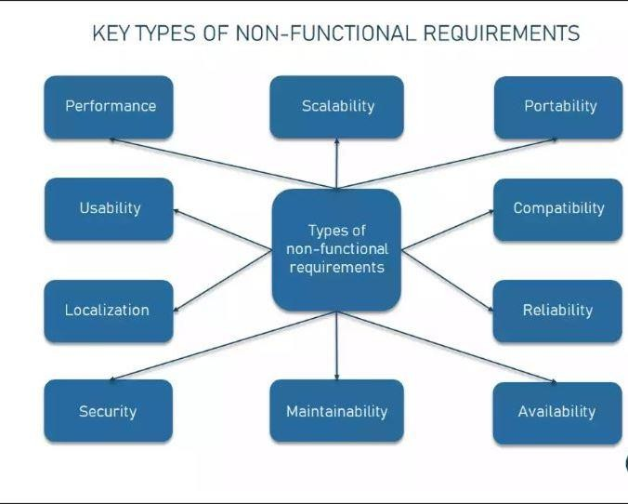

* + - **Scalability**: The system must efficiently handle increasing data volumes from sensors as the number of users grows.
    - **Security**: Ensuring data integrity and security, particularly for users' agricultural data.
    - **Usability**: The interface should be user-friendly for non-technical users, facilitating easy access to platform features.
    - **Performance**: The platform should perform real-time data processing and alerts with minimal latency.
    - **Reliability**: The system should be operational with minimal downtime and capable of recovering quickly from any breakdowns.
    - **Maintainability**: Code and system architecture should be designed for easy maintenance and updates

## CHAPTER 2 Software Design

1. ***Activity Diagram***

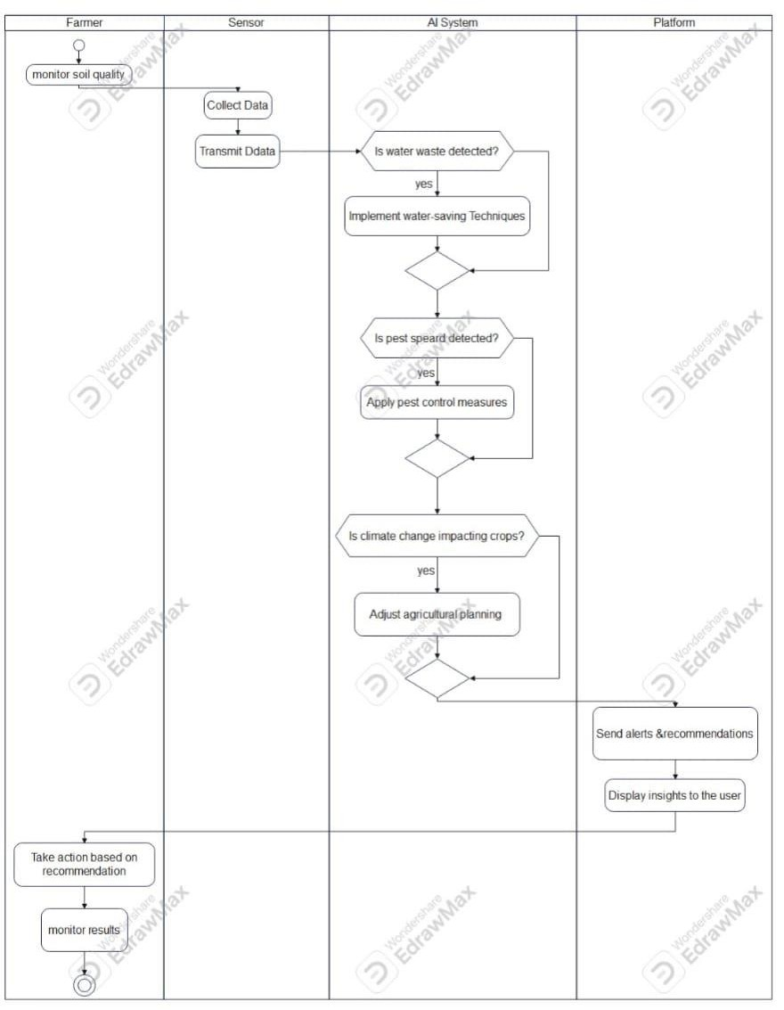

1. **Use Case Models :-**

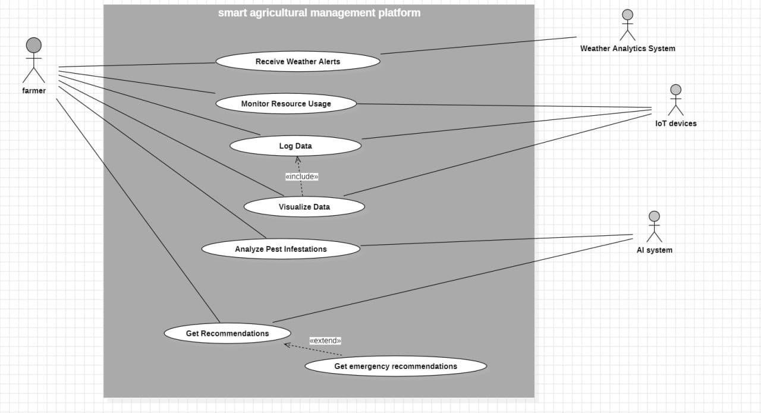

# Use Case Identification:

|  |  |
| --- | --- |
| **Identifier and Name** | UC-001  - Name: Get Recommendations |
| **Initiator** | - Actor: Farmer |
| **Goal** | The farmer wants to receive actionable recommendations to optimize resource usage and improve crop yields based on the analyzed data received from IoT devices and weather analytics. |
| **Preconditions** | 1. The farmer has a registered account on the agricultural management platform. 2. IoT devices have been set up and are actively monitoring relevant agricultural metrics (soil, moisture, etc.).  3. The AI system has access to recent data from IoT devices and weather analytics.  4. The farmer is logged into the platform. |
| **Postconditions** | The farmer receives actionable recommendations related to resource management. The recommendations are stored for record-keeping and future reference.  The recommendation system updates its data set based on any feedback provided by the farmer. |
| **Assumptions** | The AI system has been trained to provide relevant and accurate recommendations. The network connection is stable so the farmer can interact with the platform. - The IoT devices are functioning correctly and providing real-time data to the AI system. |
| **Main Success Scenario** | The farmer logs into the agricultural management platform.  The system fetches the latest data from the IoT devices and the weather analytics service.  The AI system processes the collected data using predefined algorithms. The AI system generates recommendations based on the processed data.  The platform presents the recommendations to the farmer in a user-friendly format. The farmer reviews the recommendations and decides whether to implement them. The recommendations are logged in the farmer’s activity record for future reference. |

|  |  |
| --- | --- |
| **Extensions** | * **Extension 1:** If the farmer disagrees with the recommendations: * 1. The farmer provides feedback to the system explaining their reasoning. * 2. The system records the feedback for future training of the AI model. * **Extension 2:** If IoT devices fail to provide recent data: * 1. The system alerts the farmer about missing data. * 2. The farmer checks the status of their IoT devices and resolves any issues. * 3. The farmer re-initiates the recommendation process once the data is available. * **Extension 3:** If the weather conditions change dramatically: * 1. The system re-analyzes the data based on the new weather inputs. * 2. The updated recommendations are sent to the farmer accordingly. |

1. **Sequence Daigram :-**

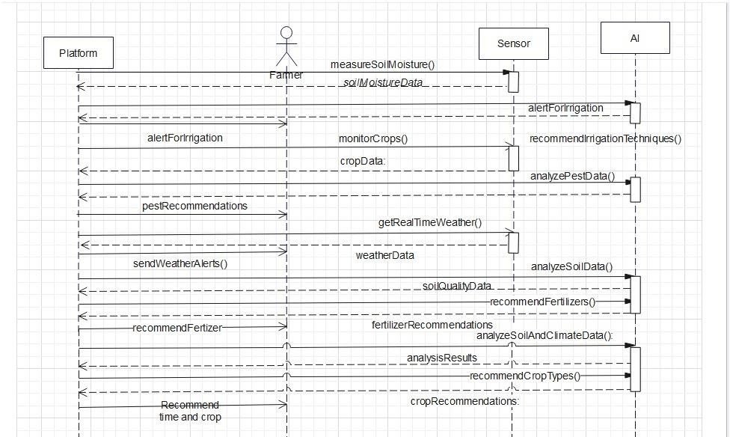

1. 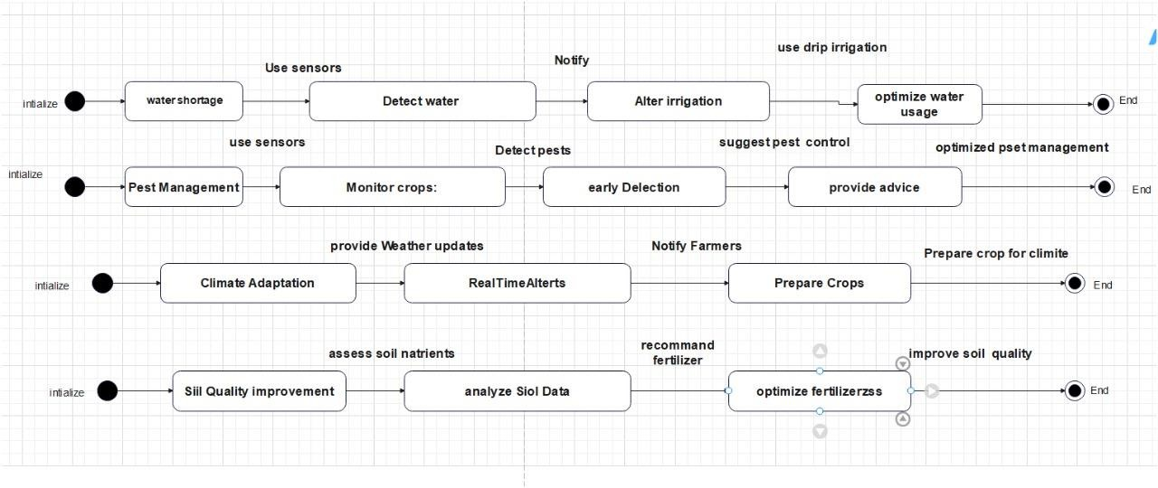**State Daigram :-**
2. **Class Daigram :-**

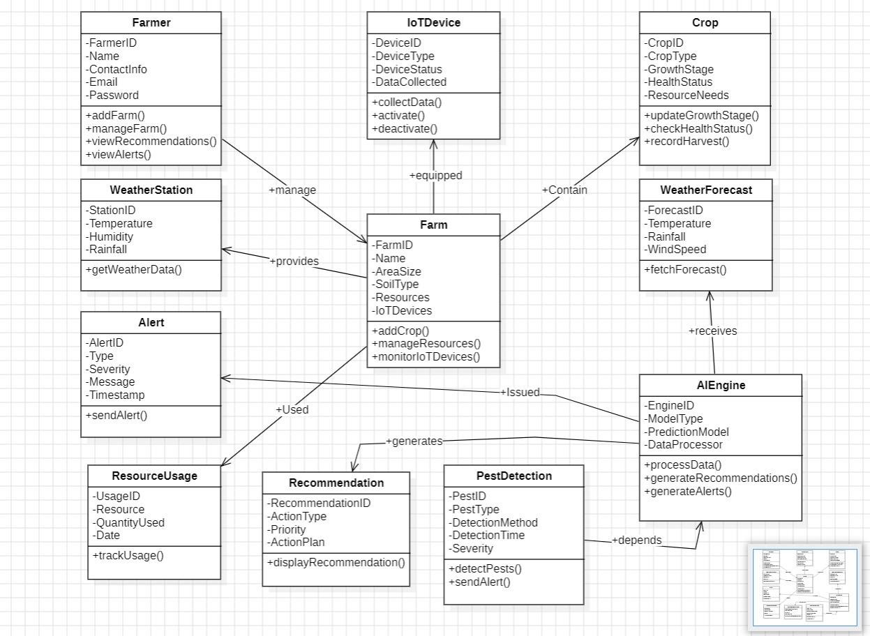

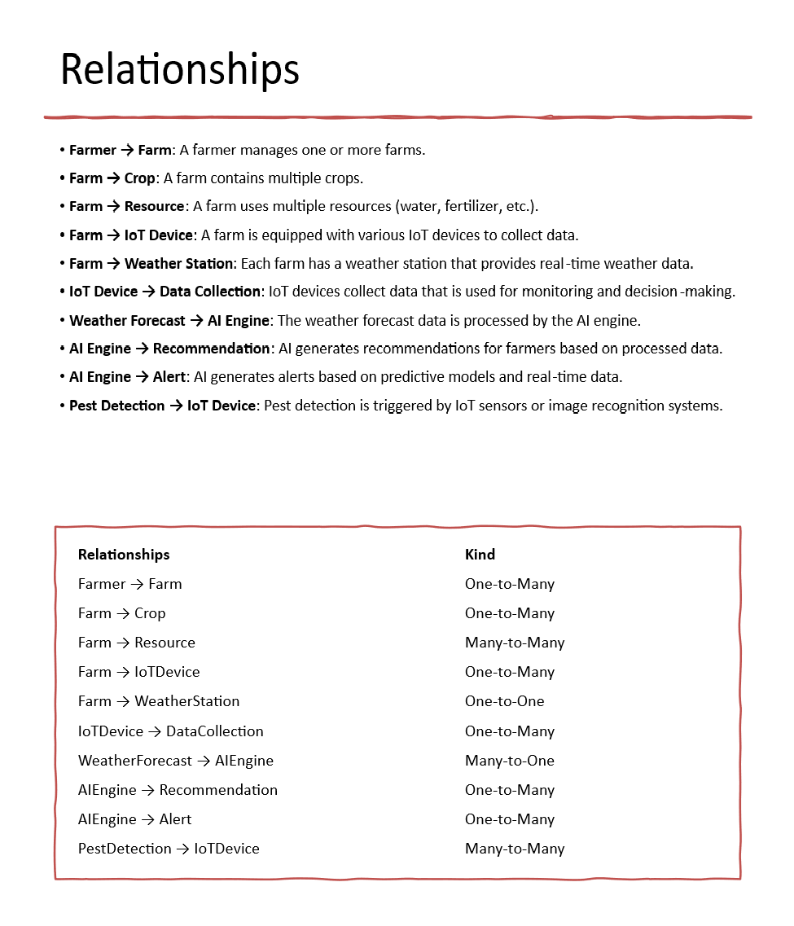

1. **Component diagrams**

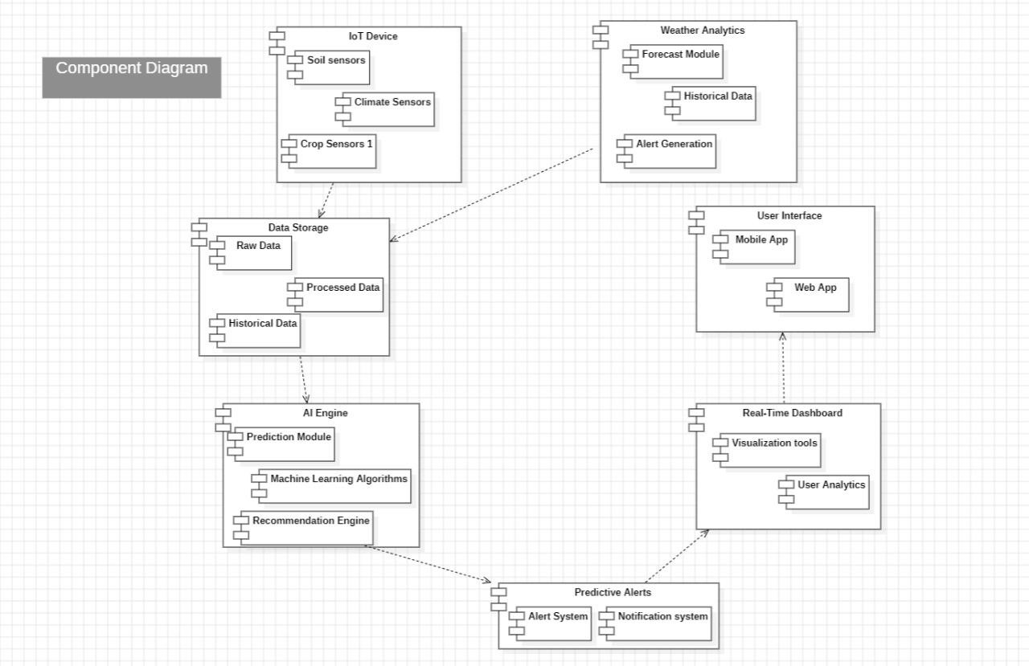

1. **Deployment diagrams**

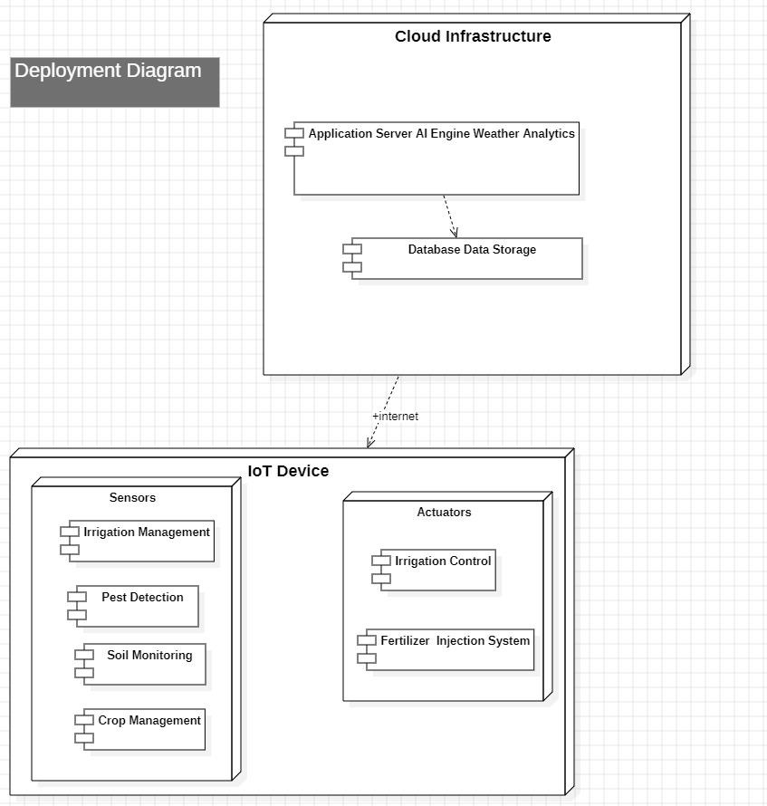

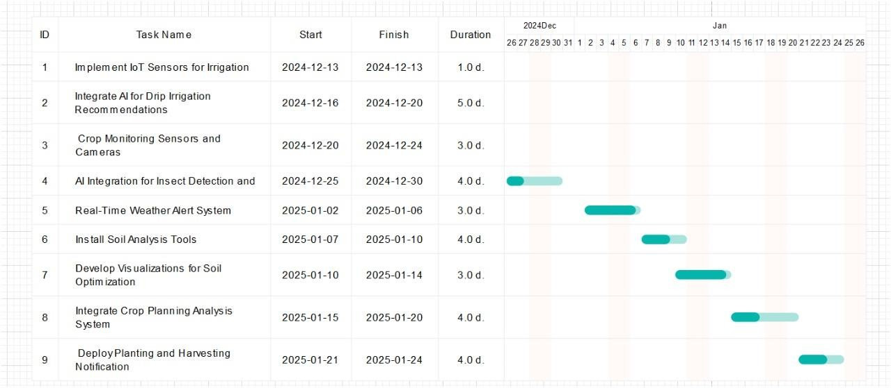**Gant Chart :-**